Dear parents,
A Wonderful Start to the New School Year!
As we settle into the new academic year, I would like to take a moment to congratulate all of our children on the fantastic way they have returned to school. It has been a real pleasure to welcome everyone back and to see our classrooms once again filled with enthusiasm, curiosity and a love of learning.
It has been an exciting start to the new Primary and although initially there were a few teething problems in terms of I.T, we are certainly beginning to smooth out these initial barriers and I thank you for your support and patience whilst this was being rectified.
The children have made an exceptionally positive start. They have quickly re-established routines, settled into their new classes and embraced the opportunities that a new school year brings. Staff across the school have mentioned how the children have adapted to new expectations and challenges.
It has been especially encouraging to see the kindness and care shown by children towards one another. Friendships have been rekindled, new relationships have been formed and the children have worked hard to ensure everyone feels included and valued. This strong sense of community is something we are incredibly proud of and is a key part of what makes our school such a special place.

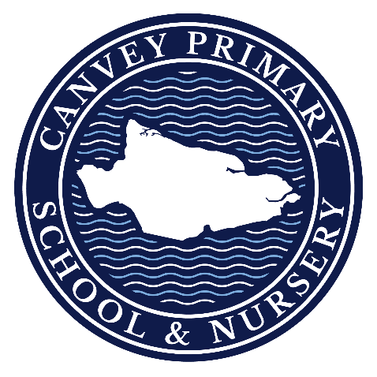

A particular mention must go to those children who may have felt nervous about returning or moving into a new year group and to those who are new to Nursery and Reception. They have shown great resilience and determination, and it has been wonderful to see their confidence grow with each passing day.
I would also like to thank our parents and carers for your continued support. Your partnership with the school plays a vital role in helping children feel secure, happy and ready to learn. By working together, we can ensure that every child has the very best opportunity to succeed.
Moving forward, please can I request that if children choose to add a key chain to their school bag, that this is only one small key chain as they can become lost or damaged as children move to and from the cloakroom areas. The year ahead promises to be full of exciting learning experiences, enrichment opportunities and memorable moments. We are looking forward to seeing all of our children continue to flourish and achieve their very best.
Mrs Townsley

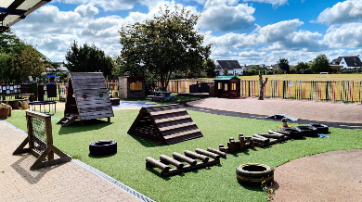
As we begin a new school year, we want to work together to help children enjoy the internet safely. Online games, videos and messages can be fun and useful, but children may also come across things that confuse or worry them.
Please keep talking with your child about what they do online and remind them they can tell a trusted adult if something doesn’t feel right. We encourage children to speak to us at school too. If you have any questions or concerns about online safety, however small, please contact us. Keeping the conversation open between home and school helps us support every child. Moee support can be found on the 2John’s website: www.esafetytraining.org

SPACE Peer Educators
We wanted to let you know about the range of free online webinars available through SPACE – Supporting Parents and Carers in Essex for parents and carers of those with SEND.
The webinars cover a wide variety of SEND-related topics, providing practical information, guidance and lived-experience support from our team of parent/carer Peer Educators. All webinars are delivered online and completely free of charge. Participation is entirely optional – attendees are not required to have camera on, ask questions or speak if they do not wish to, making them a comfortable and accessible way to access support from home.
Parents and carers are welcome to book onto as many webinars as they find helpful.
To view our upcoming webinars and book their place, please see the link below:
Online group sessions | Support for Parents And Carers in Essex
Many thanks, The Space Peer Educators


MANAGING BIG EMOTIONS
The information below is what we have received from CAVS. Parents who have previously attended, they have found it very helpful.
We are very fortunate to be able to offer a Managing Big Emotions course, facilitated by ACL. This course will be run on 2 consecutive Fridays in November between 9:30am and 12pm.
The course will take place at our Canvey Island office:
Where:
CAVS, Third Avenue Health Centre
25 Third Avenue
Canvey Island
SS8 9SU
When:
Friday 6th and 13th November, 9:30am – 12.00pm
Please see the link below for full details and for parents to be able to enrol on to the course.
https://courses.aclessex.com/CourseDetailsView.asp?CODE=HO5A02AO26&NAME=Managing+Big+Emotions+%28CAVS+only%29&ID1=9000&ID2=306114&ID3=1


The next 2 weeks:
28th Sept – Flu vaccinations
30th Sept – Girls Football Tournament
5th Oct – Firework Safety assembly
7th Oct – Boys Football Tournament
9th Oct – REAL Workshop for Nursery
& Reception parents


Last 2 weeks EYFS/KS1 Top Attendance – 2BP – 96%
Last 2 weeks KS2 Top Attendance – 4AC – 98.2%

Total Overall Attendance Winners – 3MD – 98.7%

